SLEEP SURFACES: INDICATIONS FOR USE

LOW RISK (Braden Score 15-18)

FOAM MATTRESS
(Found on brown bed frames)
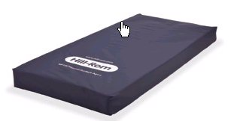
- Low risk ambulatory patient
- Weight limit up to 300 lbs.
- At risk for “bottoming out” if patient’s weight distribution is in the mid or lower body section

MODERATE RISK (Braden Score 13-14)

ZONEAIRE
(BROWN 850, ADVANCE & ADVANTA-STYLE FRAMES)
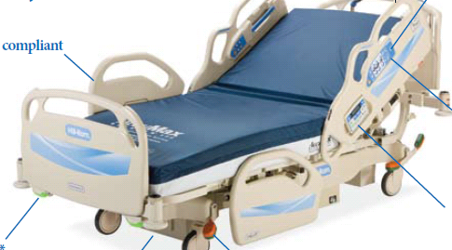

- Moderate to high-risk patient who does not require low air loss therapy
- Weight limit up to 300 lbs.
- For treatment of Stage I, II and III - VI healing pressure ulcers on one turning surface
- Automatically adjusts 3 zones within the mattress to patient’s weight distribution + 3 heels zones manually activated by caregiver
- Heel Relief Mode for the patient who is at high risk for pressure ulcer formation on heels

VERSACARE
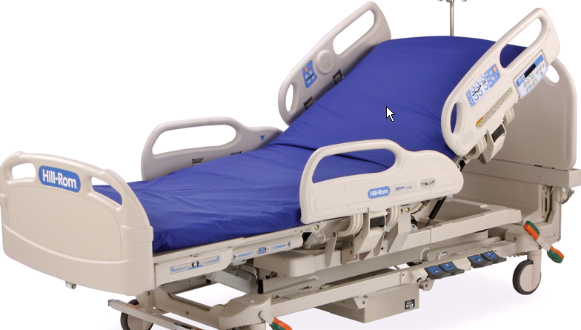

- Weight based pressure redistribution – superior to ZoneAire
- Weight limit up to 500 lbs.
- Therapeutic up to healing, uncomplicated Stage III to IV pressure ulcer on one turning surface
- Zoned mattress automatically turns on when bed plugged into electric source and mattress power button is turned on.
- In-bedded weights
- Length of bed can be adjusted 75” – 86” to fit patient
- 18” from floor to top of mattress

ACCUMAX CONVERTIBLE MATTRESS

(FOUND ON VERSACARE AND CARROLL BED FRAMES)

(Bed frame has red label, to be used for low bed option)

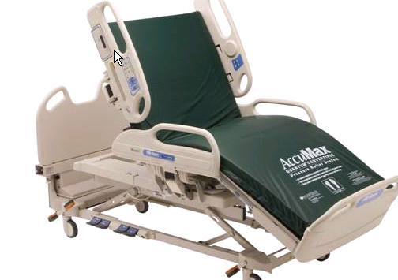
- Prevention and treatment for Stage I & II and uncomplicated III & IV pressure ulcers
- Weight limit up to 500 lbs.
- Non-powered dynamic pressure redistribution, can be converted to powered therapy by adding alternating pressure pump, found in SPD or on MAP; unit will then offer Alternating Pressure Therapy
- Sloped heel section
- 20 inches from floor to top of mattress on Carroll bed frame
- 21 inches from floor to top of mattress on VersaCare bed frame

MODERATE (Braden Score 13-14) TO HIGH RISK (Braden Score 10-12) WITH MOISTURE ISSUES

VERSACARE P500
(Bed frame has green label to indicate low air loss.)
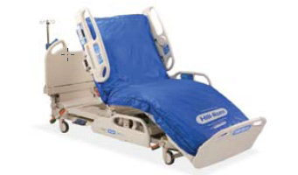

- Low air loss therapy
- Weight limit up to 500 lbs.
- Turn assist feature
- Aids in prevention/treatment of pressure ulcers up to Stage III/IV
- Egress from chair position at foot of bed. May also exit bed from side as with standard bed
- Motor driven “Intellidrive: for powered transport
- 19” from floor to top of mattress

ENVISION MATTRESS (RENTAL)
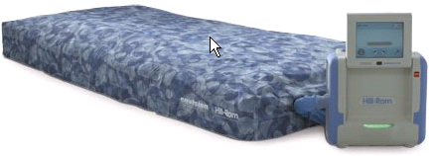

- Low air loss therapy for excessive moisture control, when our owned beds are all in use
- Step-down surface of choice from Clinitron II and immerses patient into bed surface
- Therapeutic weight limit up to 400 lbs.
- Turn assist feature
- Max Inflate feature to decrease shear and drag during patient transfers

TOTAL CARE SpO2RT THERAPY SYSTEM
(For use in Adult ICU’s only)

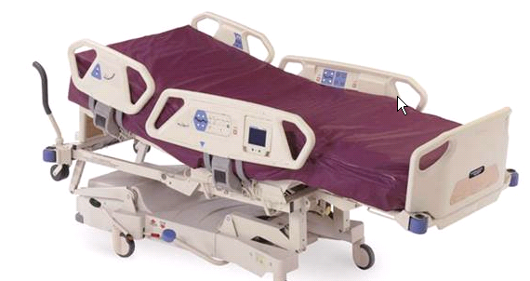
- To help with prevention and treatment of pulmonary and skin complications related to immobility
- Therapeutic weight limit up to 460 lbs.
- Removes excess heat and moisture from surface for cooler, dryer skin (microclimate control)
- 30 degree head of bed alarm and trending
- Turn assist feature
- Continuous lateral rotation therapy, percussion and vibration
- Full chair egress or may exit bed from side as with standard bed.
- Retractable foot mechanism
- Integrated scale
- Motor driven “Intellidrive: for powered transport

TOTALCARE BARIATRIC – FOAM
(Bed frame has blue label to indicate bariatric.)

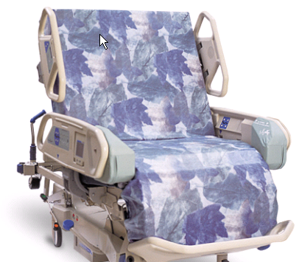

- For management of the low risk ambulatory obese patient
- Weight limit up to 460 lbs.
- Egress from chair position at foot of bed or may exit bed from side as with standard bed
- Adjustable length
- Integrated scale
- Does not accommodate overhead frame and trapeze, some beds may have patient helper
- Motor driven “Intellidrive” for powered transport

TOTALCARE BARIATRIC PLUS
(Bed frame has blue label to indicate bariatric.)

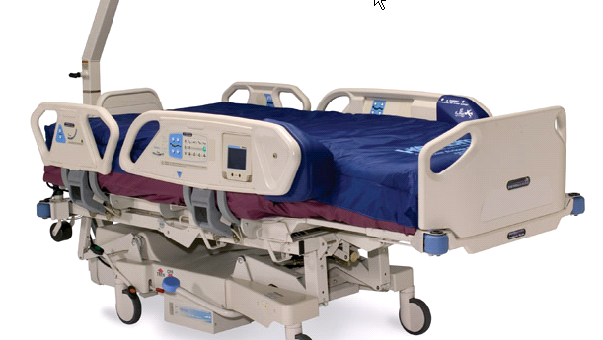
- For management of the moderate to high risk obese patient with low air loss therapy
- Weight limit up to 500 lbs.
- Egress from chair position at foot of bed or may exit bed from side as with standard bed.
- Seat deflate option for low bed height when getting in and out of bed
- 40” wide turning surface
- Adjustable length
- Turn assist feature
- Motor driven “Intellidrive” for powered transport

EXCEL BARIATRIC BED
(Bed frame has blue label to indicate bariatric.)

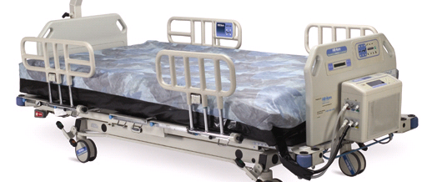

- Bariatric Foam Mattress (Low air loss option for high risk & is a rental item)
- Weight limit up to 1000 lbs.
- Trapeze specific to bed
- Integrated scale
- Not motorized
- Adjustable length
- Seat and foot deflate for low bed height
- Does NOT sit in chair position. Patient egress as with standard bed.
- Bed width can expand from 40” – 50” to accommodate patients with wider girth

VERY HIGH RISK (Braden Score of 9 or lower)

CLINITRON RITE HITE (RENTAL)

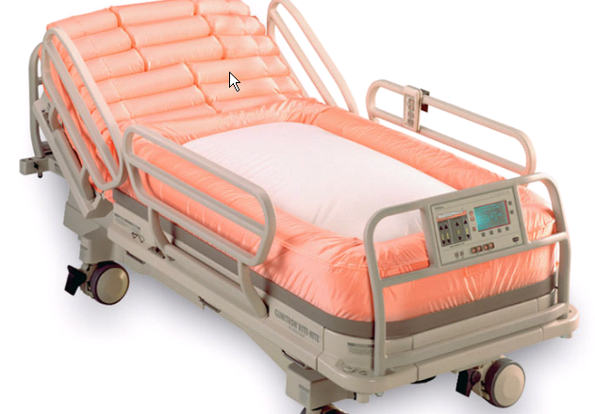

- Provides combination low air loss and air fluidized therapies
- Treatment of Stage III or IV pressure ulcers, flaps, grafts, burns and lower leg/trunk wounds, excessive maceration, intractable pain
- Weight limit up to 350 lbs.
- HOB can be raised
- Trapeze can be added
- Easier exit and transfers
- Bed does not come with a scale
- Cannot put patient in trendelenburg and reverse trendelenburg positions

CLINITRON II (RENTAL)

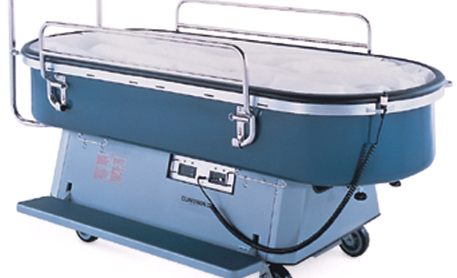

- High air flow
- Treatment of Stage III or IV pressure ulcers, flaps, grafts, full body burns, multiple areas of skin breakdown; ≤ 2 turning surfaces, Intractable pain, severe contractures with breakdown that has occurred on all previously tried surfaces
- Weight limit up to 215 lbs.
- Eliminate pressure and maceration
- Minimizes friction and shear
- HOB elevated with foam wedges only
- Trapeze available
- Wounds must be covered with occlusive dressing to maintain moisture
NOTE: Patient on Clinitron is at risk for dehydration also pneumonia if poor cough effort.

